2.Scenario: You are a data analyst working for a company that sells products online. You have been tasked with analyzing the sales data for the past month. The data is stored in a NumPy array.

Question: How would you find the average price of all the products sold in the past month? Assume 3x3 matrix with each row representing the sales for a different product

**CODE:**

import numpy as np

import pandas as pd

df = pd.read_csv(r'C:\Users\hp\Desktop\sales_data.csv', index_col=0)

sales_data = df.to_numpy()

products = ['Product A', 'Product B', 'Product C']

average_price = np.mean(sales_data)

print("Sales data (prices of products sold):")

print(sales_data)

print(f"\nAverage price of all products sold in the past month: ${average_price:.2f}")

**OUTPUT:**

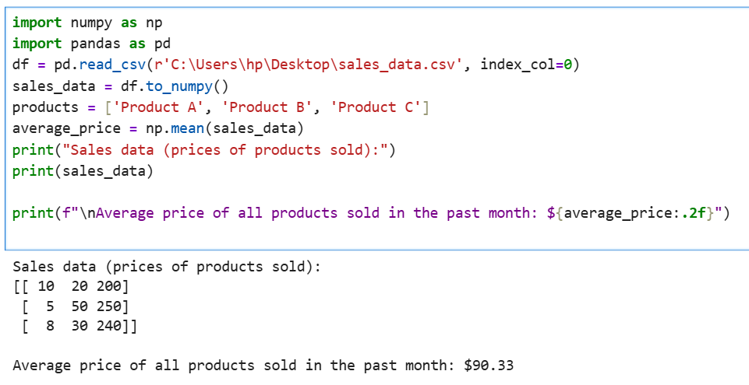

**DATASET:**

|  |  |  |  |  |
| --- | --- | --- | --- | --- |
|  | Units_Sold | Price_Per_Unit | Total_Sales | |
| Product_1 | 10 | 20 | 200 |  |
| Product_2 | 5 | 50 | 250 |  |
| Product_3 | 8 | 30 | 240 |  |
|  |  |  |  |  |